**TEMA 4**

**Ex 9**

create or replace type subordonati as varray(30) of number(3);

create table manageri (

id_manager number(10),

nume varchar2(30),

lista subordonati);

declare

v_sub subordonati:= subordonati();

v_lista manageri.lista%type;

begin

for staff_rec in (select id_staff from staff where id_echipa = 5) loop

v_sub.extend;

v_sub(v_sub.count) := staff_rec.id_staff;

end loop;

insert into manageri values (1,'Jacques',v_sub);

v_sub := subordonati();

for staff_rec in (select id_staff from staff where id_echipa = 7) loop

v_sub.extend;

v_sub(v_sub.count) := staff_rec.id_staff;

end loop;

insert into manageri values (2,'Gulie',v_sub);

v_sub := subordonati();

for staff_rec in (select id_staff from staff where id_echipa = 8) loop

v_sub.extend;

v_sub(v_sub.count) := staff_rec.id_staff;

end loop;

insert into manageri values (3,'Dan',v_sub);

select lista

into v_lista

from manageri

where id_manager=1;

for j in v_lista.first..v_lista.last loop

dbms_output.put_line (v_lista(j));

end loop;

end;

/

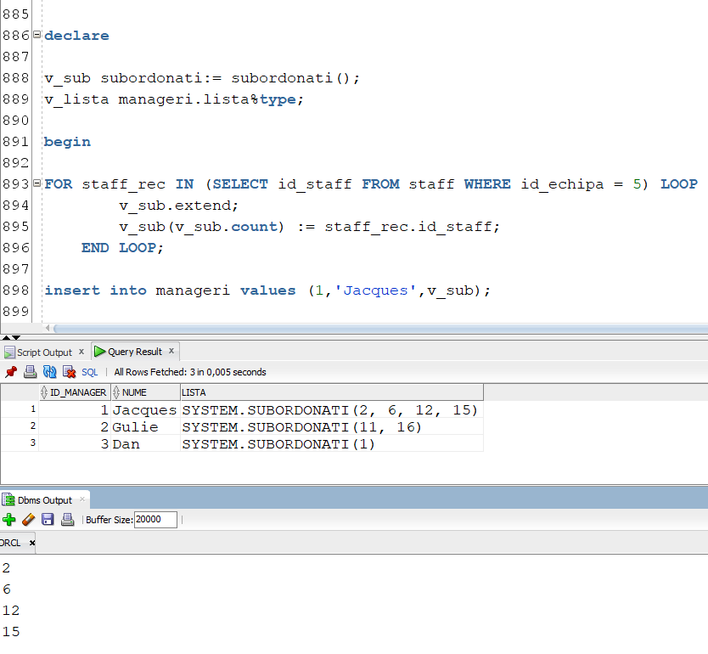

**Ex 10**

create table staff_test as

select id_staff, nume_staff

from staff

where rownum <= 2;

create or replace type tip_telefon is table of varchar2(12);

alter table staff_test

add (telefon tip_telefon)

nested table telefon store as tabel_telefon;

insert into staff_test values (3, 'Adi',tip_telefon('0721XXX', '0239XXX'));

insert into staff_test values (4, 'Mihai',tip_telefon('0727XXX', '0319XXX'));

insert into staff_test values (5, 'Andrei',tip_telefon('0745XXX', '0245XXX'));

update staff_test

set telefon = tip_telefon('0727820XXX', '0239949')

where id_staff=2;

select a.id_staff, b.*

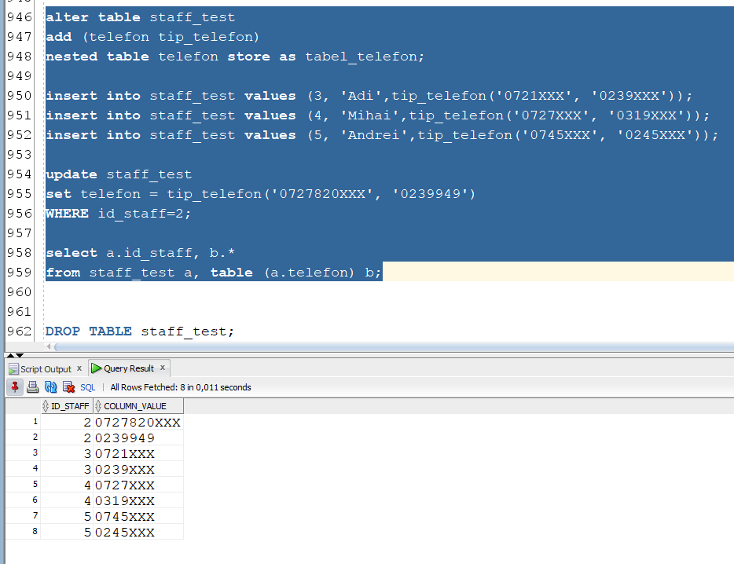from staff_test a, table (a.telefon) b;